# EE584 Power Electronics Simulation Assignment #3

## PART-I

### 1)

#### Input current at different values of ac-side inductance



Yellow line: L=1 mH, Purple Line: L = 2mH, Blue Line: L = 3 mH

From observing the graph, it can be concluded that a higher inductance will result in a lower amplitude of the peak input current, and vice versa. Also, the time to reach the peak input current is lower with lower inductance, and higher with a higher inductance.

### 2)

|  |  |
| --- | --- |
| *L* | *THD (%)* |
| 1 mH | 8.65 |
| 2 mH | 7.1 |
| 3 mH | 6.23 |

### 3)

#### Output voltage at different values of ac-side inductance



Green line: L=1 mH, Red line: L=2mH, Blue line: L = 3 mH

The plot shows that a higher ac-side inductance will result in a lower output voltage, and vice versa.

Measurements for peak to peak voltage:

**L = 1 mH**

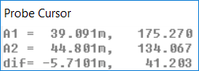

Peak-to-peak ripple = 41.2 V

**L = 2 mH**

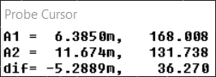

Peak-to-peak ripple = 36.27 V

**L = 3 mH**

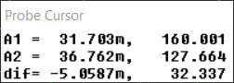

Peak-to-peak ripple = 32.3 V

#### Average value of output voltage at different values of ac-side inductance

Green line: L=1 mH, Red line: L=2mH, Blue line: L = 3 mH

Measurements for average voltage:

**L = 1 mH**

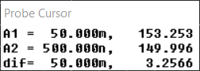

Average voltage = 153.253 V

**L = 2 mH**

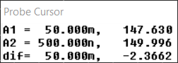

Average voltage = 147.63 V

**L = 3 mH**

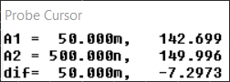

Average voltage = 142.7 V

### 4)

#### Case 1: C = 220 µF

#### Input current



THD = 8.38%

#### Output voltage



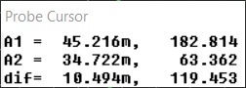

Peak-to-peak voltage = 119.453 V

#### Average output voltage



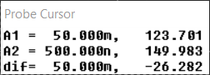

Average voltage: 123.701 V

#### Case 2: C = 470 µF

#### Input Current



THD = 9.36 %

#### Output Voltage



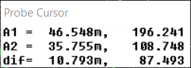

Peak-to-peak ripple = 87.493

#### Average output voltage



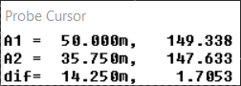

Average output voltage = 149.338 V

#### 5)

#### Capacitor current with different values of ac-side inductor



Green line: L=1 mH, Red line: L=2mH, Blue line: L = 3 mH

**L = 1 mH**

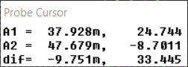

Peak-to-peak current = 33.45 A

**L = 2 mH**

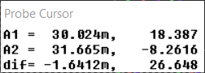

Peak-to-peak current = 26.65 A

**L = 3 mH**

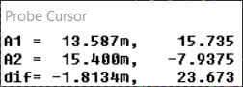

Peak-to-peak current = 23.67 A

#### Spectrum of capacitor current



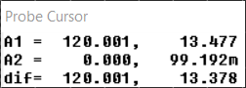

Fundamental frequency is at 120 Hz

### 6)

#### Capacitor current when C = 220 µF

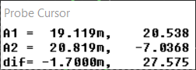

Peak-to-peak current = 27.575 A

#### Capacitor current when C = 470 µF



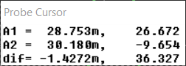

Peak-to-peak current = 36.327 A

#### Capacitor current when C = 1000 µF



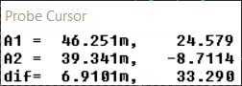

Peak-to-peak current = 33.29 A

## PART-II

### 1)

#### Input voltage to boost converter and output voltage



Red curve: output voltage, Green curve: input voltage to boost converter

#### Inductor current



### 2)

#### Harmonic components of inductor current:

FOURIER COMPONENTS OF TRANSIENT RESPONSE I(L_L1)

DC COMPONENT = 8.161372E-01

HARMONIC FREQUENCY FOURIER NORMALIZED PHASE NORMALIZED

NO (HZ) COMPONENT COMPONENT (DEG) PHASE (DEG)

1 6.000E+01 5.968E-03 1.000E+00 6.363E+00 0.000E+00

2 1.200E+02 5.580E-01 9.350E+01 -8.392E+01 -9.665E+01

3 1.800E+02 4.022E-04 6.739E-02 -1.106E+02 -1.297E+02

4 2.400E+02 1.083E-01 1.814E+01 -7.883E+01 -1.043E+02

5 3.000E+02 1.098E-04 1.841E-02 -9.199E+01 -1.238E+02

6 3.600E+02 4.933E-02 8.266E+00 -7.425E+01 -1.124E+02

7 4.200E+02 7.258E-05 1.216E-02 -1.085E+02 -1.531E+02

8 4.800E+02 2.888E-02 4.839E+00 -7.070E+01 -1.216E+02

9 5.400E+02 2.669E-05 4.473E-03 -1.156E+02 -1.729E+02

10 6.000E+02 1.938E-02 3.248E+00 -6.809E+01 -1.317E+02

11 6.600E+02 2.858E-05 4.789E-03 -1.038E+02 -1.737E+02

12 7.200E+02 1.412E-02 2.366E+00 -6.654E+01 -1.429E+02

13 7.800E+02 1.802E-05 3.020E-03 -1.417E+02 -2.244E+02

14 8.400E+02 1.083E-02 1.815E+00 -6.578E+01 -1.549E+02

15 9.000E+02 1.016E-05 1.703E-03 -1.062E+02 -2.016E+02

16 9.600E+02 8.619E-03 1.444E+00 -6.587E+01 -1.677E+02

17 1.020E+03 1.478E-05 2.476E-03 -1.385E+02 -2.467E+02

18 1.080E+03 7.012E-03 1.175E+00 -6.666E+01 -1.812E+02

19 1.140E+03 5.710E-06 9.568E-04 -1.646E+02 -2.855E+02

20 1.200E+03 5.813E-03 9.740E-01 -6.806E+01 -1.953E+02

21 1.260E+03 9.438E-06 1.581E-03 -1.282E+02 -2.619E+02

22 1.320E+03 4.872E-03 8.163E-01 -7.021E+01 -2.102E+02

#### Harmonic components of capacitor current:

FOURIER COMPONENTS OF TRANSIENT RESPONSE I(C_Co)

DC COMPONENT = -1.265283E-03

HARMONIC FREQUENCY FOURIER NORMALIZED PHASE NORMALIZED

NO (HZ) COMPONENT COMPONENT (DEG) PHASE (DEG)

1 6.000E+01 3.475E-03 1.000E+00 5.982E+00 0.000E+00

2 1.200E+02 4.706E-01 1.354E+02 -8.569E+01 -9.766E+01

3 1.800E+02 8.781E-04 2.527E-01 -1.597E+02 -1.777E+02

4 2.400E+02 4.981E-03 1.434E+00 1.397E+02 1.158E+02

5 3.000E+02 7.967E-05 2.293E-02 1.707E+02 1.407E+02

6 3.600E+02 1.536E-04 4.419E-02 1.260E+02 9.009E+01

7 4.200E+02 5.460E-05 1.571E-02 -1.651E+02 -2.070E+02

8 4.800E+02 1.163E-04 3.346E-02 1.534E+02 1.055E+02

9 5.400E+02 2.537E-05 7.300E-03 1.424E+02 8.853E+01

10 6.000E+02 6.597E-05 1.899E-02 1.636E+02 1.038E+02

11 6.600E+02 1.215E-05 3.497E-03 -1.376E+02 -2.034E+02

12 7.200E+02 7.710E-05 2.219E-02 -1.768E+02 -2.486E+02

13 7.800E+02 1.805E-05 5.193E-03 1.607E+02 8.297E+01

14 8.400E+02 6.568E-05 1.890E-02 1.776E+02 9.382E+01

15 9.000E+02 1.199E-06 3.451E-04 7.585E+01 -1.387E+01

16 9.600E+02 6.711E-05 1.931E-02 -1.672E+02 -2.629E+02

17 1.020E+03 1.151E-05 3.312E-03 -1.660E+02 -2.677E+02

18 1.080E+03 7.293E-05 2.099E-02 -1.760E+02 -2.837E+02

19 1.140E+03 6.636E-06 1.910E-03 1.127E+02 -9.266E-01

20 1.200E+03 6.380E-05 1.836E-02 -1.722E+02 -2.918E+02

21 1.260E+03 5.362E-06 1.543E-03 -1.242E+02 -2.498E+02

22 1.320E+03 7.418E-05 2.135E-02 -1.733E+02 -3.048E+02

### 3)



The equation states that the current to the output stage consists of a DC part and the second harmonic. This can also be seen in the spectrum in the figure above.

### 4)

#### Output voltage and voltage at input of boost converter

#### Inductor current

#### 

#### Harmonic content of inductor current

FOURIER COMPONENTS OF TRANSIENT RESPONSE I(L_L1)

DC COMPONENT = 8.101991E-01

HARMONIC FREQUENCY FOURIER NORMALIZED PHASE NORMALIZED

NO (HZ) COMPONENT COMPONENT (DEG) PHASE (DEG)

1 6.000E+01 5.439E-03 1.000E+00 7.995E+00 0.000E+00

2 1.200E+02 5.542E-01 1.019E+02 -8.377E+01 -9.976E+01

3 1.800E+02 1.885E-04 3.465E-02 -9.685E+01 -1.208E+02

4 2.400E+02 1.069E-01 1.965E+01 -7.959E+01 -1.116E+02

5 3.000E+02 5.204E-05 9.567E-03 -1.041E+02 -1.440E+02

6 3.600E+02 4.838E-02 8.895E+00 -7.724E+01 -1.252E+02

7 4.200E+02 5.668E-05 1.042E-02 1.817E+01 -3.779E+01

8 4.800E+02 2.760E-02 5.074E+00 -7.540E+01 -1.394E+02

9 5.400E+02 1.890E-04 3.474E-02 3.876E+01 -3.319E+01

10 6.000E+02 1.792E-02 3.295E+00 -7.626E+01 -1.562E+02

11 6.600E+02 3.088E-04 5.677E-02 5.389E+01 -3.406E+01

12 7.200E+02 1.320E-02 2.427E+00 -7.733E+01 -1.733E+02

13 7.800E+02 1.790E-04 3.291E-02 4.311E+01 -6.083E+01

14 8.400E+02 9.625E-03 1.770E+00 -8.084E+01 -1.928E+02

15 9.000E+02 1.218E-04 2.238E-02 8.999E+01 -2.993E+01

16 9.600E+02 6.961E-03 1.280E+00 -8.792E+01 -2.158E+02

17 1.020E+03 3.115E-04 5.726E-02 -1.225E+02 -2.584E+02

18 1.080E+03 5.978E-03 1.099E+00 -9.432E+01 -2.382E+02

19 1.140E+03 1.002E-04 1.843E-02 1.865E+01 -1.333E+02

20 1.200E+03 4.687E-03 8.616E-01 -9.903E+01 -2.589E+02

21 1.260E+03 2.680E-04 4.927E-02 -7.254E+01 -2.404E+02

22 1.320E+03 4.037E-03 7.422E-01 -1.106E+02 -2.864E+02

#### Harmonic content of capacitor current

FOURIER COMPONENTS OF TRANSIENT RESPONSE I(C_Co)

DC COMPONENT = -2.841961E-03

HARMONIC FREQUENCY FOURIER NORMALIZED PHASE NORMALIZED

NO (HZ) COMPONENT COMPONENT (DEG) PHASE (DEG)

1 6.000E+01 3.765E-03 1.000E+00 5.985E+00 0.000E+00

2 1.200E+02 4.675E-01 1.242E+02 -8.563E+01 -9.760E+01

3 1.800E+02 8.562E-04 2.274E-01 -1.789E+02 -1.969E+02

4 2.400E+02 5.392E-03 1.432E+00 1.459E+02 1.220E+02

5 3.000E+02 5.192E-04 1.379E-01 -1.233E+02 -1.532E+02

6 3.600E+02 2.152E-04 5.715E-02 -1.105E+02 -1.464E+02

7 4.200E+02 4.610E-04 1.224E-01 8.880E+01 4.690E+01

8 4.800E+02 9.373E-04 2.490E-01 9.768E+01 4.980E+01

9 5.400E+02 2.415E-04 6.415E-02 -3.995E+01 -9.382E+01

10 6.000E+02 1.355E-03 3.598E-01 -1.205E+02 -1.804E+02

11 6.600E+02 3.296E-04 8.755E-02 1.387E+02 7.290E+01

12 7.200E+02 9.471E-04 2.516E-01 -9.723E+01 -1.690E+02

13 7.800E+02 6.096E-04 1.619E-01 -2.736E+01 -1.052E+02

14 8.400E+02 1.528E-03 4.059E-01 9.209E+01 8.298E+00

15 9.000E+02 5.647E-04 1.500E-01 -1.522E+02 -2.420E+02

16 9.600E+02 1.207E-03 3.205E-01 1.239E+02 2.816E+01

17 1.020E+03 2.237E-04 5.942E-02 1.370E+02 3.527E+01

18 1.080E+03 4.141E-04 1.100E-01 -8.554E+01 -1.933E+02

19 1.140E+03 6.594E-04 1.751E-01 7.777E+00 -1.059E+02

20 1.200E+03 2.636E-04 7.001E-02 8.440E+01 -3.529E+01

21 1.260E+03 7.916E-04 2.102E-01 -1.212E+02 -2.469E+02

22 1.320E+03 7.643E-04 2.030E-01 -9.672E+01 -2.284E+02